**Technical Document - Annexure I**

**of**

**Beauty parlour service v1.0**

**Contents**

Annexure I 3

1. Project Overview 3

2. Technologies 4

3. User Flow Diagram 5

4. Features and Scope of Work 6

4.1. User Flow of end user 6

4.2. Administrator Web Panel 9

5. Project Management 11

6. Proposed Team of Project 12

# Annexure I

# Project Overview

* **Business Need**

To develop a platform where end user can book beauty parlor service.

* **How the platform would help in achieving the business need**

The platform makes it simple to book beauty parlor appointments. Users can easily schedule and customize their appointments and will visit the parlor and get real-time updates.

* **Stakeholders**

|  |  |
| --- | --- |
| **Actor** | **Task** |
| End user | End user can browse the parlour services and book the appointment |
| Admin | Managing the complete platform using the Admin Panel |

* **Project Scope and Development Deliverables**

This project scope comprises of the following components to deliver:

* Design and Development of Mobile Application for end users (iOS & Android)
* Development and Integration of API
* Development of Admin Web Panel

# Technologies

|  |  |  |
| --- | --- | --- |
| **Development Phases** | | **Tools & Technology** |
| Requirement  Gathering and Analysis | Proposal Drafting, SRS Writing and User Flow Diagram | Microsoft Office Word 2019 / Microsoft Office Presentation 2019 / Microsoft Office Vision 2019 |
| Wire Framing | Axure / UiZard |
| Development | Application | Flutter / React Native |
| Web Backend | Node.js / PHP (Laravel) |
| Database | MongoDB / MySql |
| Version/s Supported | Android | 9.0 and above |
| iOS | 13.0 and above |
| Browser | Google Chrome, Safari, Mozilla Firefox |
| Quality Assurance  & Testing | Test Cases | MS Office Excel 2019 |
| Testing | Manual |

# User Flow Diagram

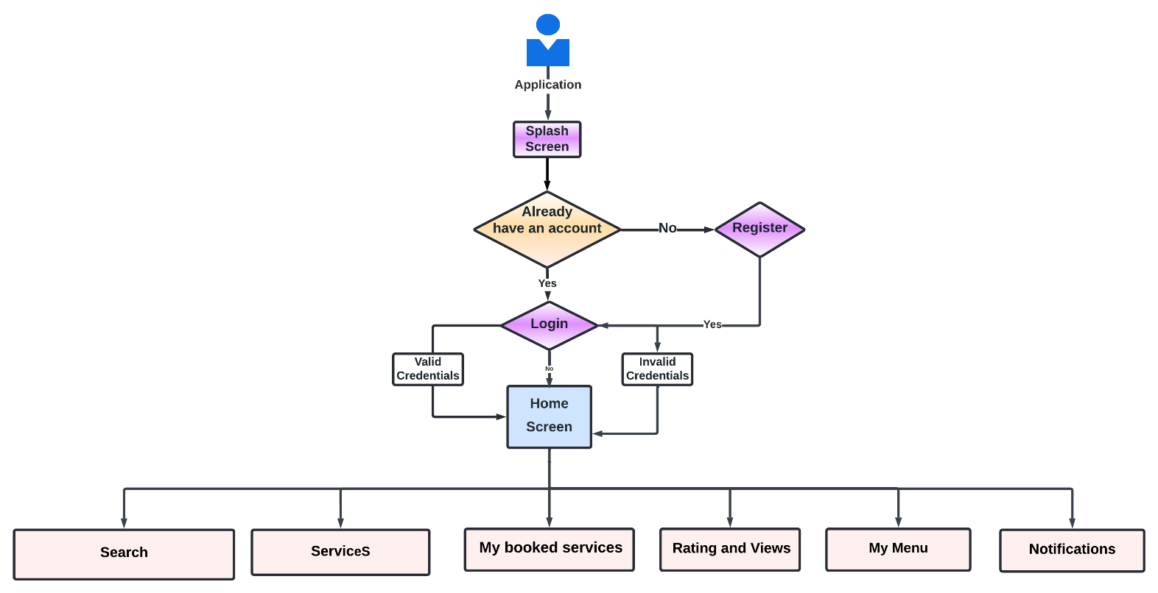

# Features and Scope of Work

## User Flow of end users

* **Splash Screen**
  + Launch screen of the application which will have the business logo and name.
* **Register / Sign-up**
  + This functionality would allow users to create an account by entering the below details: -
    - * Name
      * Mobile Number/E-mail ID
      * Password
      * Confirm Password
* **Login**
  + This functionality would be used by users to log in to the application using below credentials: -
    - * Mobile Number/E-mail ID
      * Password
* **Forgot Password**
  + This functionality would allow users to recover their password which would be verified through OTP which would be received on e-mail ID or mobile number.
* **Home page**
  + **User will able to view following elements in home page.**
    - Home screen
    - Search
    - Service
    - My booked services
    - Rating and Views
    - My menu
    - Notifications
* **Home screen:**
  + The home screen of the beauty salon app showcases a search bar, featured services, and dynamic content. Icons for My Cart, My Menu, and Notifications facilitate easy access. The footer navigation ensures quick and user-friendly interactions.
* **Search**
  + User will be able to search any beauty parlor treatment services using this section, as per there need.
  + They will able see the result and can click to particular services they want.
* **Services**
  + Users will be able to view all the listed services with the below details, they will select service and book the appointment on the App
    - Service Name
    - Description
    - Book Appointment (calendar view)
    - They can see the availability
    - User will able to book the online service and make payment online.

**Note- For booking any appointment, users will have to Sign up/Sign in on the platform.**

* **My booked services**
  + User will able see present, upcoming and past service which they have booked.
  + They also cancel the service if they want.
  + Users will be able to rebook the appointment for the same service on the app, in case want to postpone.
  + End user can also rate the service.
* **Rating and Views**
  + Users can see the feedback and ratings of other customers.
  + User can also upload the images as a feedback.
* **Notification**
  + Users will receive all the notification related to application.
  + Appointment Booked Notifications.
  + Any type of refund etc.
  + Service completion.
* **My menu**
  + User will able view following elements
    - **My Account**
      * Profile- Users will be able to view/edit their profile details: - Name, Email address & Phone Number.
      * Change Password- Users will be able to change their password.
      * Service Booking History- Users will be able to view appointment booked history and upcoming booking details on the App.
      * Logout- Users will be able to logout from the App.
    - About Us
    - Terms and Conditions
    - Privacy Policy
    - Contact Us

## Administrator Web Panel

The back end of the platform will be power packed with an administrative panel to manage the updates of data at the application level, website level and as well as back end.

Following would be the key functionalities:

* **Login**   
  Admin will able to login the panel
* **Users Management**
  + Admin will be able to view/search the list of all users of the platform.
  + Admin will be able to activate or deactivate the account of the users.
  + Admin will be able to view the complete profile of the user using this option.
* **Manage Services**
  + Admin will be able to manage Services from the admin panel.
  + Admin will be able to View/Search/Add/Remove the Services from the admin panel.
  + Admin will be able to manage (Add/Remove/Edit) service charge (Price) and details from the admin panel.
* **Manage Booking & Availability**
  + Admin will be able to manage and view user’s booking details from the admin panel.
  + Admin will be able to manage the booking availability time from the admin panel.
  + Admin will be able to view user’s booking daily basis in the calendar from the admin pane.
  + Admin will be able to book appointments for the clients from the admin panel.
  + Admin will be able to change the user’s booked appointment times from the admin panel.
  + Admin will be able to view the wait list of the clients to book appointments if any cancellations will happen, Admin will book the appointment of the waiting list clients from the admin panel.

**Note- Admin will get the update of the user's response on the auto reminders of the booking.**

* **Notification Management**
  + Admin will be able manage notificationsfrom the admin panel.
  + Admin will share the new updates from the admin panel.
* **Contact Us Management**
  + Admin will be able to manage & view the user’s issues from the admin panel.
  + Admin will provide the resolution to the Users based on their issues.
* **General Management**
  + Manage About Us, Terms & Condition.
  + Manage App Images and Content.
* **Logout**
  + Admin will able to logout the panel

# Project Management

|  |  |  |  |
| --- | --- | --- | --- |
| **Before Project is awarded** | | | |
| **Business Analysis** | **Project Management / Software Development** | **Business Development / Sales** | **Accounting** |
| 1. Project Identify / Analysis 2. Develop one-page proposal overview 3. Create project management overview 4. **Chantal** assigned to business manager GBM   *GBM: Global Business Manager* | 1. Project Evaluation by technical teams 2. Introduction call 1 on 1 interaction with **Chantal** 3. System appropriate services determined 4. Requirements / System application architecting 5. Project needs analysis 6. Detailed proposal development 7. Cost and Time effort estimation | 1. Introduction call 2. Deliverables discussed with **Chantal** 3. Milestones discussed 4. Project success discussed 5. Future growth alignment 6. Detailed proposal provided 7. Payment instructions | 1. Invoice submitted to **Chantal** 2. Payment received 3. Payment confirmation sent to **Chantal** 4. Account forwarded to PM |

|  |  |  |  |
| --- | --- | --- | --- |
| **After Project is awarded** | | | |
| **Phase 1** | **Phase 2** | **Phase 3** | **Phase 4** |
| 1. Project manager assigned 2. Project initiation/ introduction call 3. Online project profile created 4. Weekly project meetings scheduled 5. Reporting formats explained to Chantal | 1. Design, Development / technical teams assigned 2. Project start 3. **Chantal** feedback on weekly 4. Weekly project feedback session- 30 min 5. Reports available on-line 6. Online Rebel catering access of PM system application | 1. Testing / Quality Assurance 2. Live server   testing 3. Final bugs issues fixed 4. Campaign completed | 1. Periodic project maintenance 2. Data backups 3. Web site –System application upgrades 4. On line marketing ** Optional |

# Proposed Team of Project

The proposed team to achieve the deliverables in a time span of _____ Business Weeks   
 comprising of 40 hrs./week is as follows

|  |  |
| --- | --- |
| Designation | Availability |
| Project Manager | Part Time |
| Project Expert | Part Time |
| Designers | Full Time |
| Developers | Full Time |
| Quality Analyst | Full Time |

**IN WITNESS WHEREOF**, both parties here have to agree the finalized scope for this project as of the date.

**For: Chantal For: WebMobril Inc.**

Signature: Signature:   
_________________________ ________________________